Seasons Word Search

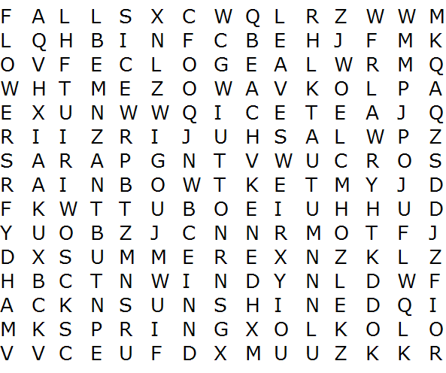
WINTER  SUMMER  SPRING  AUTUMN  FALL  FLOWERS  SNOW  RAIN | SUNSHINE  WINDY  LEAVES  ICE  STORM  BEACH  RAINBOW

